Machine Learning & Big Data

Assignment 6

Introduction

In this assignment, we will analyze 2 things:

1) How to use sci-kit functions to train a neural network model

2) Using cross-validation and test sets to choose a degree to polynomial

Figure 1.1 & 1.2

* We are overfitting our examples
* We created our model and obtained a prediction

o The model was trained by sci-kit function

* We just used training set and test set
  + %67 training, % 33 test

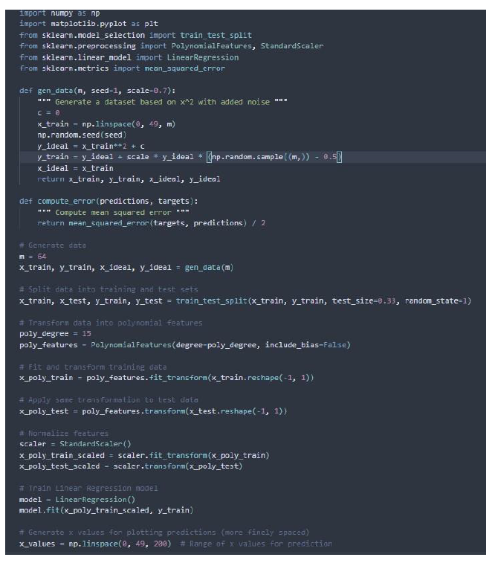

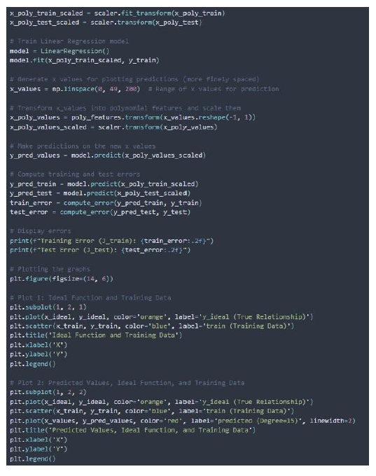

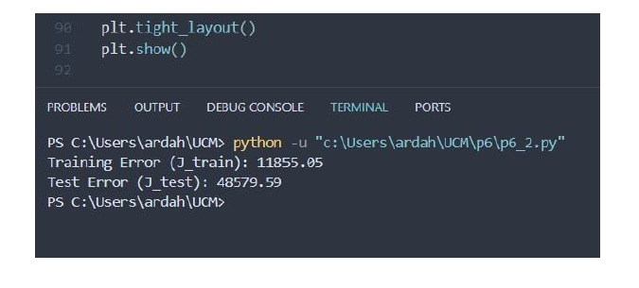

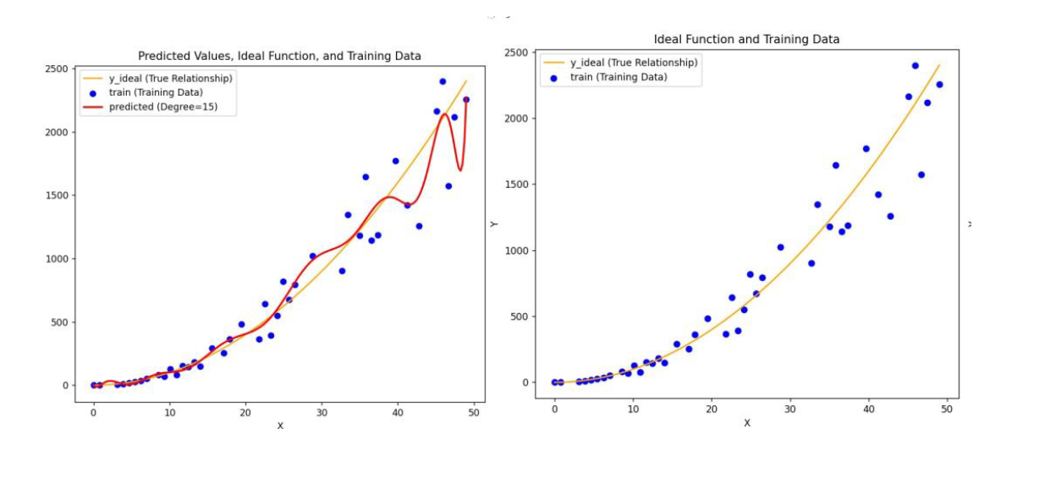

Fig 1.3

* We are now using cross-validation set also
  + %60 training, %20 cross-validation, %20 test set
* We are not regularizing, yet…

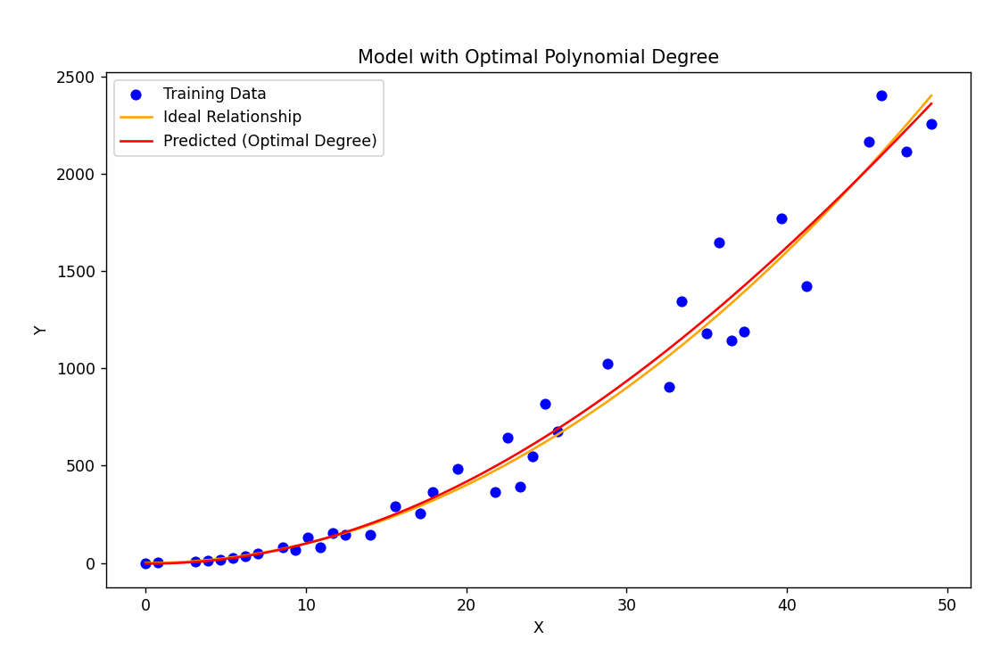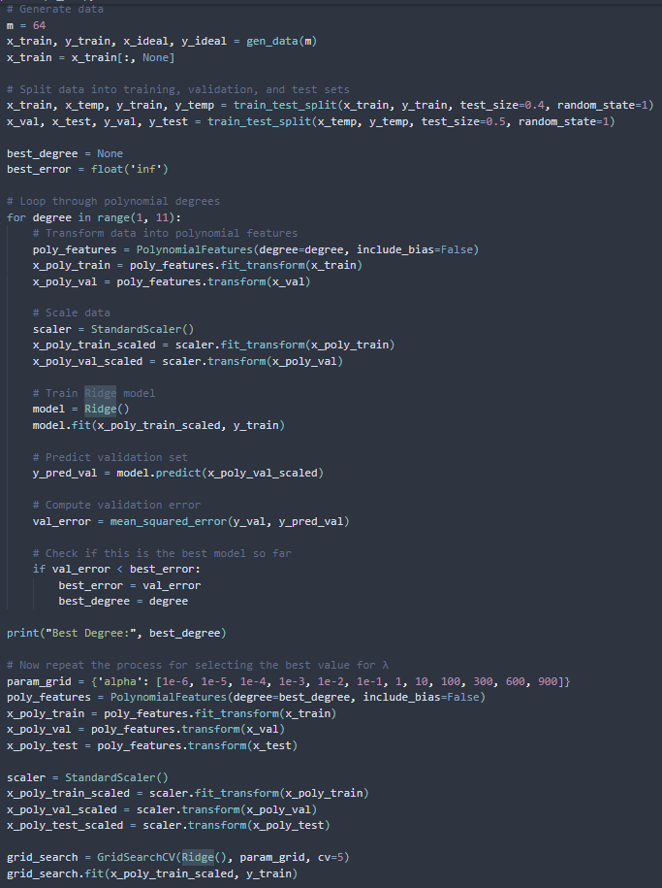

Fig 1.4

* Now we are also regularizing

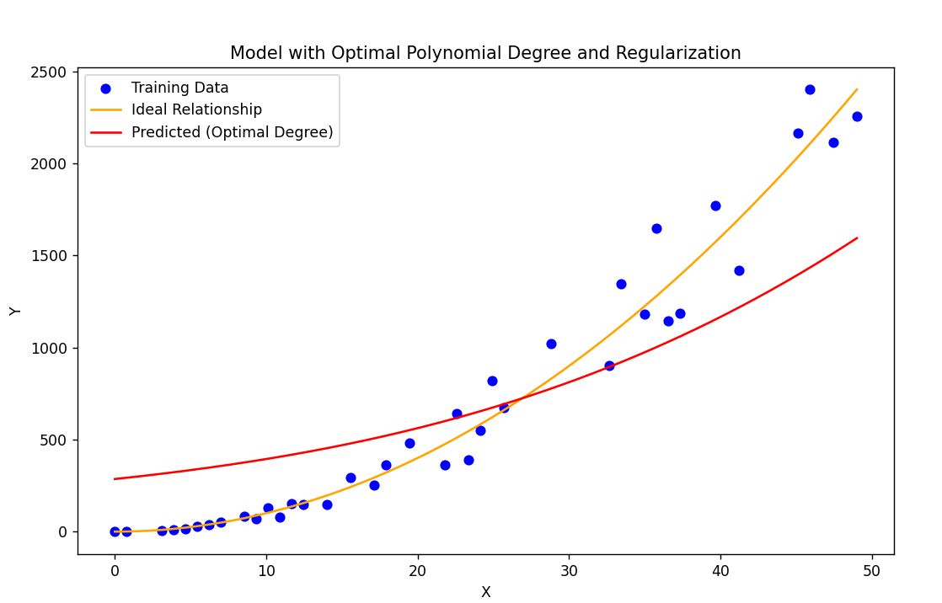

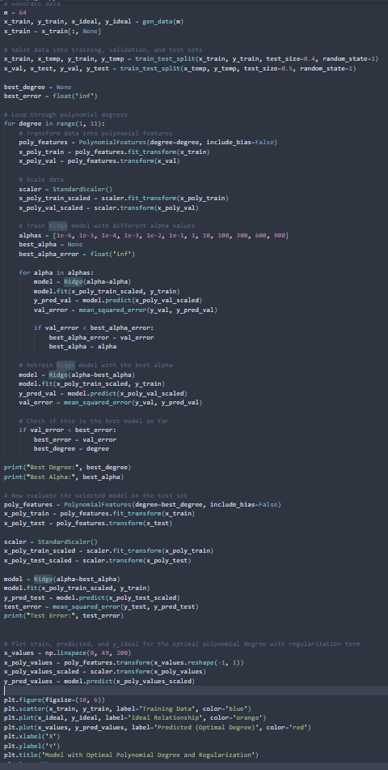

Fig 1.5

* We are increasing our data size to 750
  + We are training with hyper-paramters

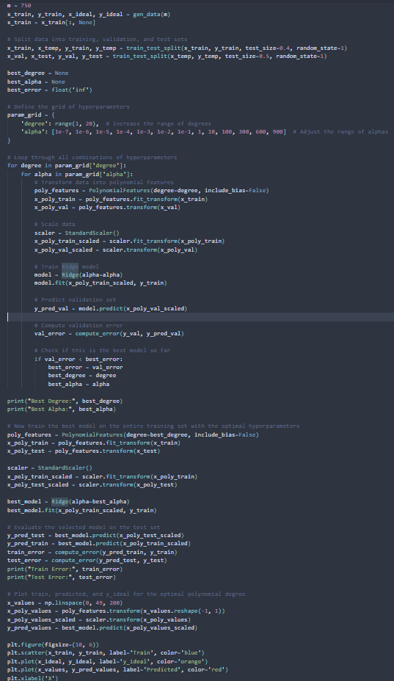

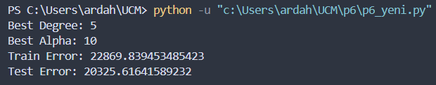

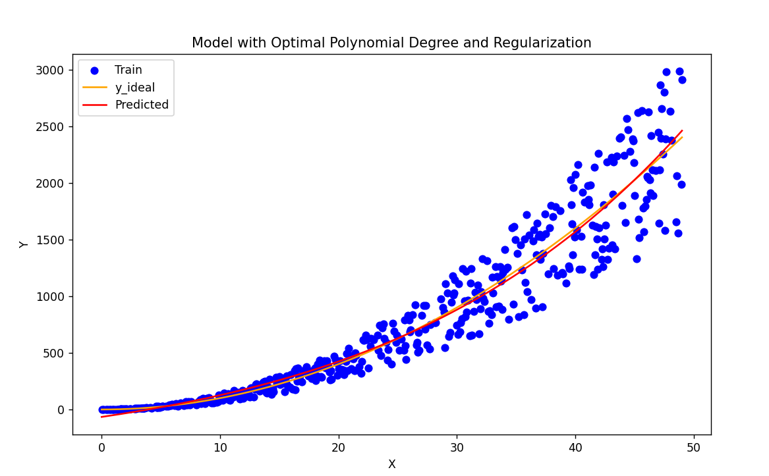

Fig 1.6

* We are getting our training-error and cross-validation error

